The Three Wishes
One day, three friends decided to go on a trip. John was from New York. Paul was from California. Tim was from North Carolina. They went to Florida to get on a small boat to sail in the Atlantic Ocean. During their trip, there was a big storm. It could have been a Hurricane. The sky was full of dark clouds. There was thunder and lightning. It rained very hard. The waves got very big. The wind was very strong. Their small boat was broken by the big waves. The boys had to swim and float on boards from the boat. After two days in the water they saw an island. They were glad to be alive and reach dry land. The sand on the beach was very white. There were many plants and trees on the beach. They were also afraid of wild animals that might be there. It looked like a beautiful place but they were really lost and scared. They didn’t even have a compass to tell them what direction was north, south, east or west.

There was a tall cliff and they could see a cave in the rock. There was a river and waterfall coming over the top of the cliff. The hot sun made a rainbow in the splashing water. They climbed the rocks to get out of the sun and rest in the cave. When the boys reached the cave they were happy. It was much cooler in the cave. The boys were very tired and went to sleep. When they woke up, they were amazed to see what looked like icicles and ice-cream. It was cool but not cold enough to freeze water. The cave had many stalactites from the ceiling and stalagmites on the floor. The boys also saw something else that was very odd to be in the cave. It was a small strange shaped bottle. They picked it up and opened it.

A strange smoke came out of the bottle and then they saw something that looked like a man. It was like the story of Aladdin and the magic lamp. The man was really a Genie!

The genie thanked the boys for letting him out of the bottle. He then told the boys he would give them three wishes. John spoke first and said, “I wish I was back in New York with my wife and children.” Before Paul and Tim could blink, John was gone. Paul saw what happed and said, “I wish I was back in California with my mother and father.” And he was gone!

Tim was all alone in the cave and the Genie asked him what he wanted to wish. Tim had so many things in his mind he wanted to wish for. The genie waited a very long time. Finally the Genie asked, “What wish do you want to wish?” Tim said, “I don’t know. I wish Paul and John were here to help me decide.” All of a sudden, Paul and John were back in the cave. Tim was so happy to see his friends again. The Genie started laughing and then disappeared.

Be careful what you wish for!
QUESTIONS:
1) Have you ever been in a bad storm?
2) Has there been a time when you were so scared you did not know what to do?
3) Have you ever gotten lost?
4) If you had three wishes, what would you wish for?
5) Do you think there is such a thing as a Genie and magic wishes?
6) Have you ever wished for something and then were disappointed when you got it?

 | 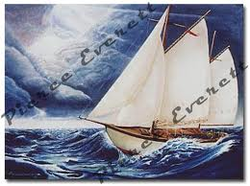 | 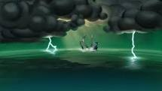
 |  | 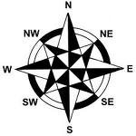
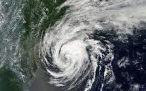 | 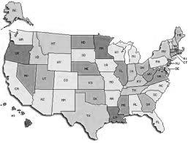
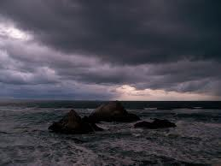 | 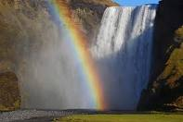 | 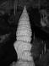
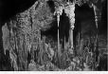 | 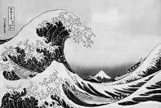 | 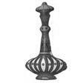
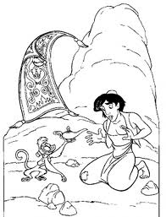
Cave Sites: http://www.goodearthgraphics.com/showcave.html

Virtual Cave: http://www.goodearthgraphics.com/virtcave/stalmite/stalmite.html

Wikipedia: http://en.wikipedia.org/wiki/Stalagmite

Geology: http://www.jimloy.com/geology/stalac.htm

Cave Tours: http://www.caverntours.com/KIDSPAGE_Form_Stalagmite.html

How Stuff Works:
http://science.howstuffworks.com/dictionary/famous-scientists/geologists/stalactite-stalagmite.htm

Famous US Caves:
  - Carlsbad Caverns, New Mexico
  - Mammoth Cave, Kentucky
  - Linville Caves, North Carolina

Ships in a storm Videos:
- http://www.youtube.com/watch?v=t-HaTWIznGE
- http://www.youtube.com/watch?v=nvh2hCxUvJA
- http://www.youtube.com/watch?v=KTm_uEGxI_s
- http://www.youtube.com/watch?v=Jld5pIUKhCE

Aladin – A Whole New World
- http://www.youtube.com/watch?v=HJ0nLzTvSQo
- http://www.youtube.com/watch?v=-kl4hJ4j48s&feature=related
- Friend Like Me: http://www.youtube.com/watch?v=DKi1eWgho_E&feature=related

Temperature Conversion:
Centigrade to Fahrenheit Fahrenheit to Centigrade
(C * 9) + 32 = F (F – 32) x 5
5 9
C | F
0 | 32 | freeze water
37 | 98.6 | body temperature
100 | 212 | boil water

