Legend of the Sand dollar
http://mail.aol.com/33790-111/aol-1/en-us/mail/DisplayMessage.aspx?ws_popup=true
http://www.first-school.ws/activities/animals/ocean/sandollar.htm

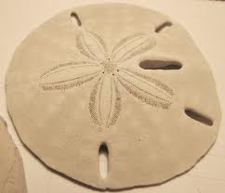
Version One
There’s a pretty little legend
That I would like to tell
Of the birth and death of Jesus
Found in this lowly shell.
If you examine closely,
You’ll see that you find here
Four nail holes and a fifth one
Made by a Roman’s Spear.
On one side the Easter Lily,
Its center is the star
That appeared unto the shepherds
And led them from afar.
The Christmas poinsettia
Etched on the other side
Reminds us of His birthday
Our Happy Christmastide.
Now break the center open
And here you will release
The five white doves waiting
To spread Goodwill and Peace.
This simple little symbol,
Christ left for you and me
To help us spread the Gospel
Through all eternity.
Anonymous
Version Two
Upon this odd-shaped sea shell
A legend grand is told
About the life of Jesus
The wondrous tale of old.
The center marking plainly shows
The well known Guiding Star
That led to tiny Bethlehem
The Wise Men from afar.
The Christmas flower, Poinsettia
For His Nativity
The Resurrection too is marked
The Easter Lily, see.
Five wounds were suffered
by our Lord
From nails and Roman’s spear
When He died for us on the cross
The wounds show plainly here.
Within the shell, should it be broke
Five Doves of Peace are found
To emphasize the legend
So may Love and Peace abound.

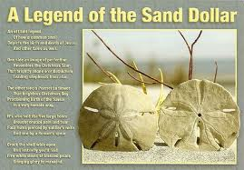
Sand Dollars live in the warm waters in Florida, Georgia, South and North Carolina.

