Name
Long Vowel u
Name each picture. Circle the pictures that have a sound of long u.
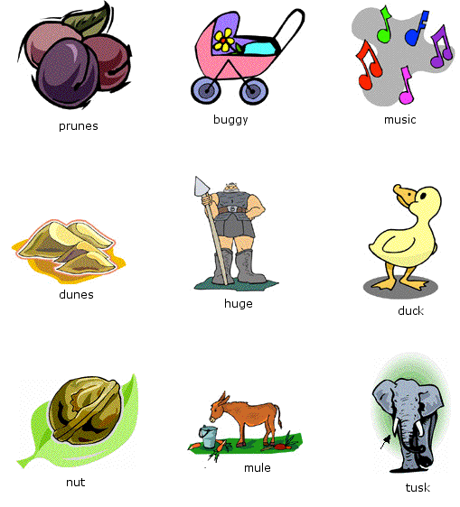

Copyright@2014 SchoolExpress

