http://members.enchantedlearning.com/phonetic/longi.shtml
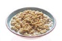  oatmeal  Oatmeal is a cereal. | Obama, Barack H.  Barack Obama is the 44th President of the USA. | 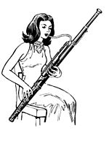  oboe  The oboe is a woodwind instrument with a double reed. | ocean  An ocean is a large body of salt water that surrounds a continent. Oceans cover more the two-thirds of the Earth's surface | 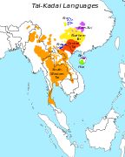  Oceania  Oceania is a region of islands in the Pacific Ocean, including the Salomon Islands, Micronesia, Kiribati, Fiji, Tonga, Polynesia, Australia, and others.

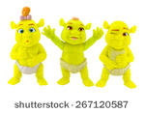  ogre  Ogres are ugly, scary and make-believe. | 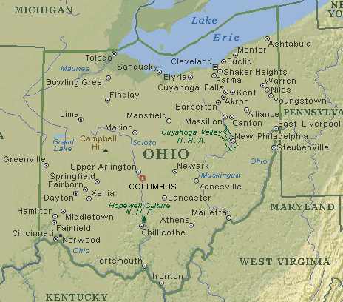  Ohio  Ohio is a state in the United States of America. Its capital is Columbus. | 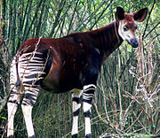  okapi  The okapi is a nocturnal, giraffe-like mammal from African rainforests. | 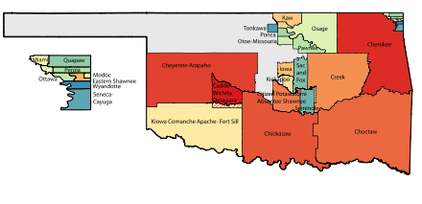  Oklahoma  Oklahoma is a state in the United States of America. Its capital is Oklahoma City.

old  When someone or something is old, it has been around for a long, long time. | 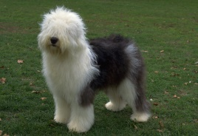  old English sheepdog  The old English sheepdog is an affectionate, long-haired dog that was originally bred in Great Britain. | open  Something that is open is not shut. The door is open. | oval  An oval is an egg-shaped figure.

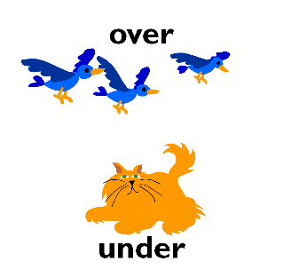  over  The cloud is over the mountain. | 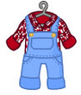  overalls  Overalls are baggy pants with shoulder straps and a piece of fabric covering the chest. | 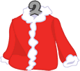  overcoat  An overcoat will keep you warm when it is cold. | 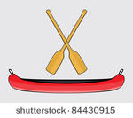  Oar  A paddle used in a small boat to steer the boat

