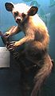  aye-aye  The aye-aye is an unusual, nocturnal primate that lives in Madagascar | eye  We see with our eyes. Our eyes give us a sense of sight. | 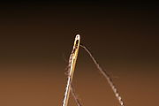  Eye  Thread goes through the  eye of a needle. | 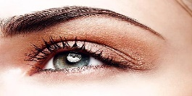  eyebrow  The eyebrows are dense patches of hair above the eyes.
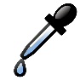  eyedropper  An eyedropper is used to drop liquids one drop at a time. |  | 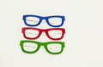  eyeglasses  Eyeglasses help some people see more clearly. | 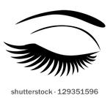  eyelash  Eyelashes are long hairs on the edges of the eyelids. | 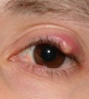  eyelid  Eyelids are flaps of skin that cover and protect our eyes.
I  I is a word that refers to the person who is speaking or writing. | 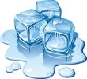  ice  Ice is frozen water. | 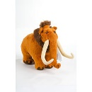Ice Age  An Ice Age is a time when the Earth becomes very cold and much of it is covered with ice and glaciers. There have been many Ice Ages on Earth; the last one lasted from about 2 million to 10,000 years ago. | 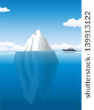iceberg  An iceberg is a huge chunk of ice that floats in the sea. Most of an iceberg is hidden under the water. | 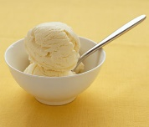  ice cream  Ice cream is cold, creamy, and sweet treat.
ice cream cone  An ice cream cone is nice to eat on a hot summer day. | 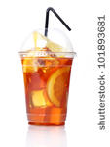  iced tea  Iced tea is a cold drink. | 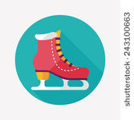  ice skate  When you wear ice skates, you can glide across ice. | 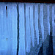  icicle  Icicles are hanging ice that are formed from dripping water. | 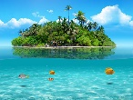  An island is a piece of land that is surrounded by water.
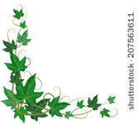  ivy  Ivy is a vine | idea  When you have an idea, you think of something new. |  | 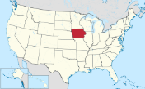  Iowa  Iowa is a state in the United States of America. Its capital is Des Moines.
Ireland  Ireland is an island off western Europe. | 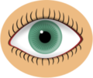  iris  The colored part of the eye around the pupil is the iris. | 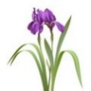  iris  Irises are beautiful flowers with long, thin, flat leaves. | iron  Irons press the wrinkles out of clothes. | 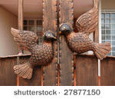  iron  Iron is a common metal that is used for many things, like train tracks, pots, and pipes.

